Question bank on Unit 4
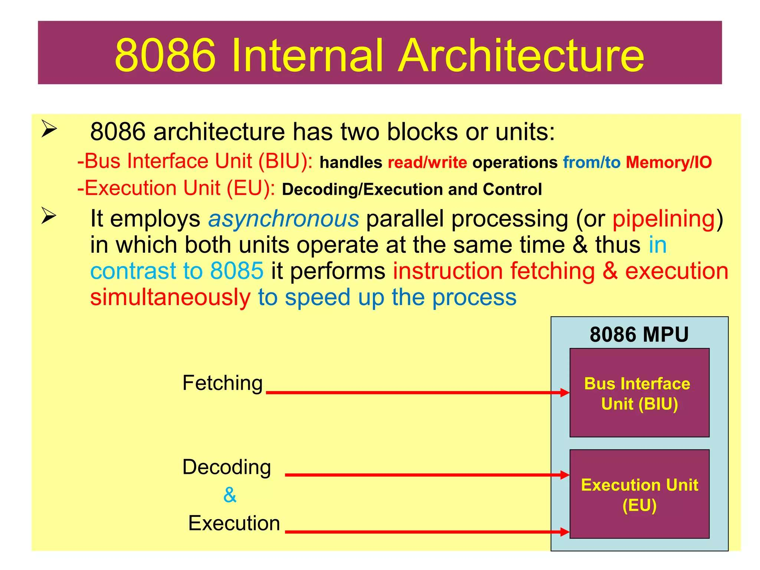
- Explain the internal architecture of the 8086 microprocessor with the help of a neat block diagram.
Ans:

- Explain the role of the EU and BIU in improving the performance of the 8086 processor.
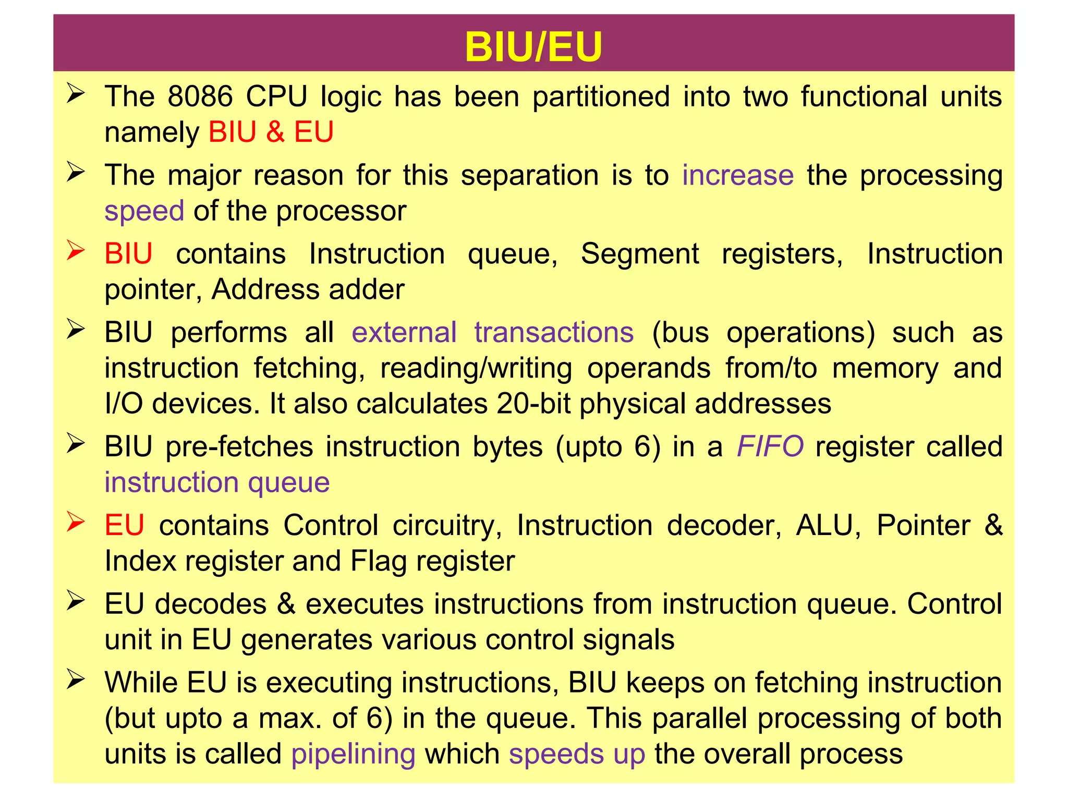
Ans:

- Define physical address in 8086. How is it generated from segment and offset addresses?
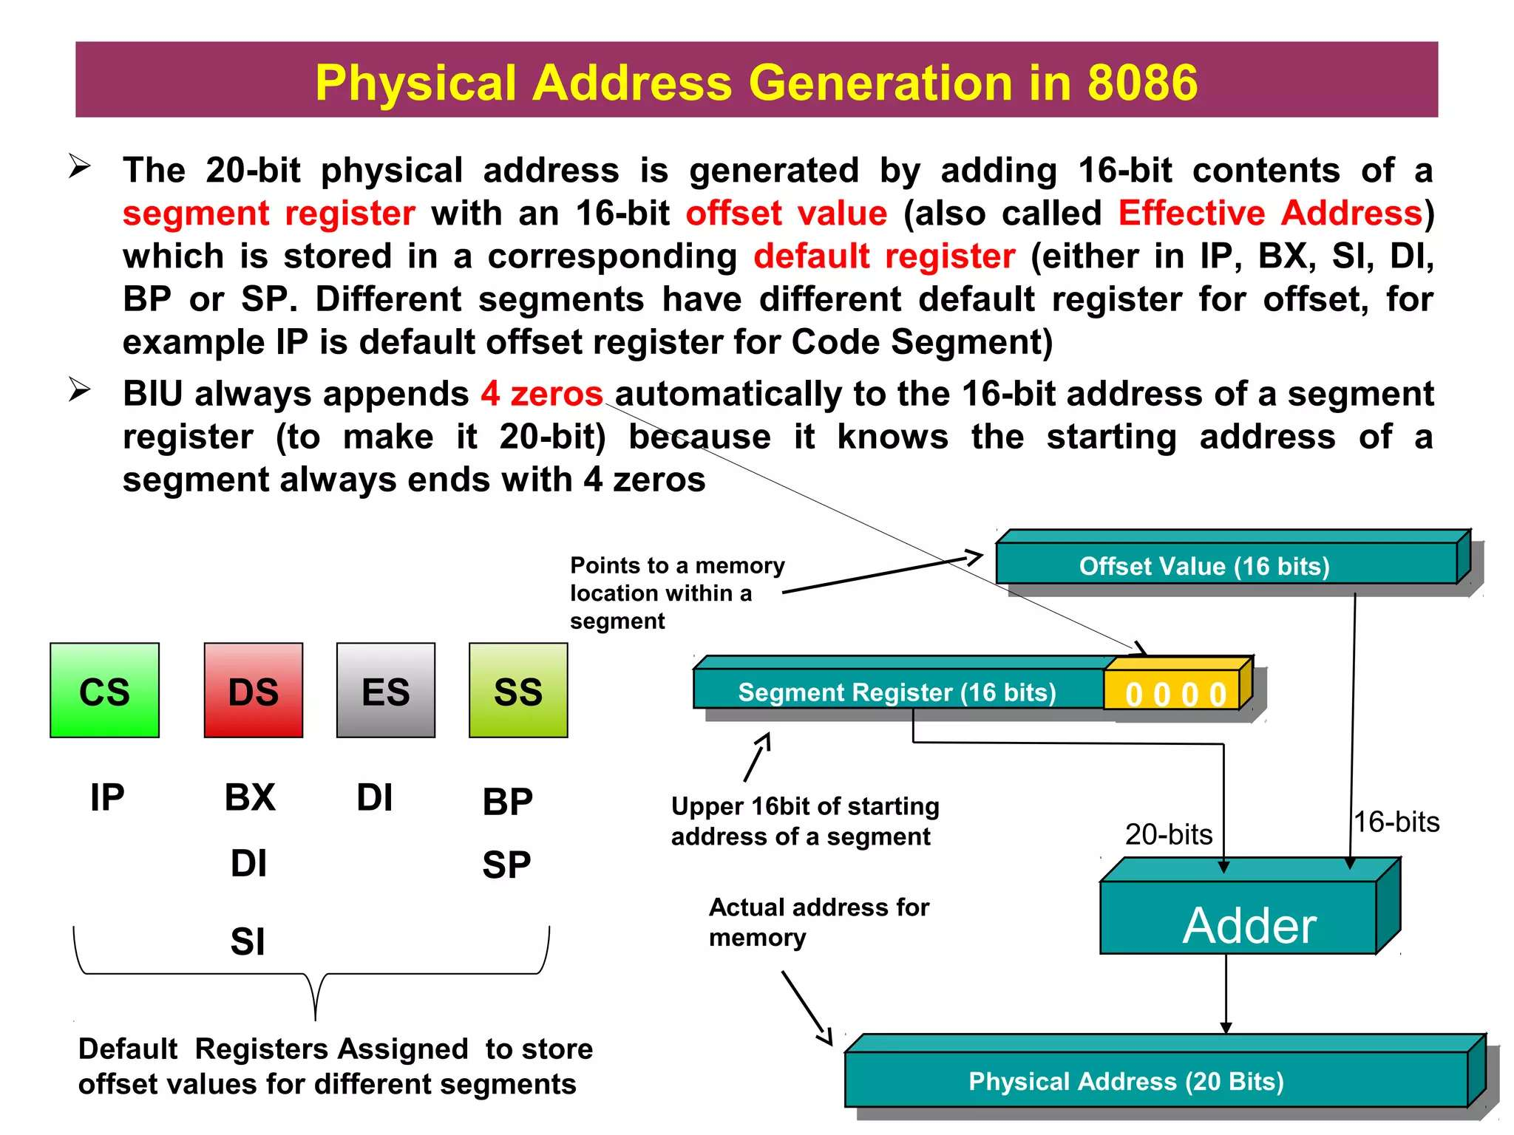
Ans:

- Explain a segmentation scheme for a program requiring code, stack, and data segments, extra segments.
Ans:
- In 8086, a program's memory is organized into up to four active 64KB segments, which can be located anywhere in the 1MB memory space.
- Code Segment (CS): Stores the program's executable instructions. The IP register points to the offset of the next instruction here.
- Data Segment (DS): Stores the program's variables and data. The SI or DI registers often hold offsets within this segment.
- Stack Segment (SS): Used for the stack to store return addresses, parameters, and temporary data. The SP register points to the top of the stack.
- Extra Segment (ES): An additional data segment, primarily used as the destination for string manipulation instructions.
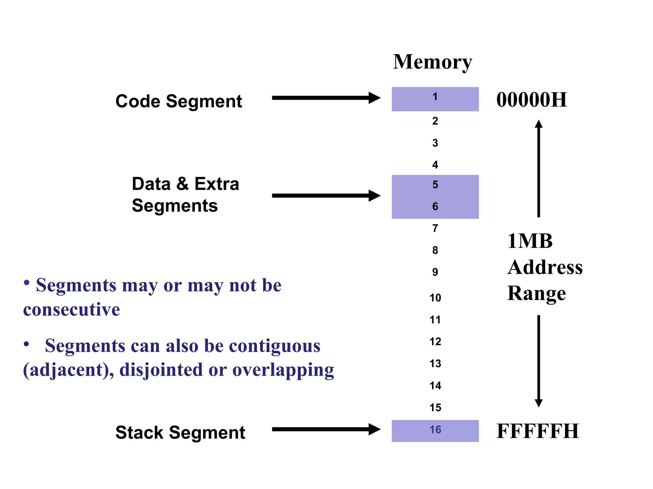
- This scheme allows for organization and protection, as code, data, and stack can be placed in different memory regions.

- List and describe the different types of registers available in 8086.
Ans:
The 8086 has 14 registers, categorized as follows:
- General-Purpose Registers (16-bit, can be used as 8-bit):
  - AX (Accumulator): For arithmetic, I/O, multiplication, and division.
  - BX (Base): Can hold a memory offset in based addressing.
  - CX (Count): Used as a loop and shift/rotate counter.
  - DX (Data): Used for multiplication/division and I/O port addressing.
- Pointer and Index Registers (16-bit): Used to hold memory offsets.
  - SP (Stack Pointer): Points to the top of the stack.
  - BP (Base Pointer): Points to a location within the stack.
  - SI (Source Index): Used as a source pointer in string operations.
  - DI (Destination Index): Used as a destination pointer in string operations.
- Segment Registers (16-bit): Hold the base addresses of memory segments.
  - CS (Code Segment), DS (Data Segment), SS (Stack Segment), ES (Extra Segment).
- Instruction Pointer (IP): A 16-bit register holding the offset of the next instruction to execute in the code segment.
- Flag Register: A 16-bit register with 9 status and control flags.

- Explain the role of segment registers and how they differ from general-purpose registers.
Ans:
• Role of Segment Registers: Their sole purpose is to hold the 16-bit base addresses of the 64KB memory segments (Code, Data, Stack, Extra). They are essential for the 8086's ability to address 1MB of memory.
• Differences:
Function: General-purpose registers (AX, BX, etc.) hold data, while segment registers hold segment base addresses.
Use: General-purpose registers are used in arithmetic and data manipulation. Segment registers are automatically used by the CPU to calculate the physical address for memory access (e.g., CS for instruction fetch, SS for stack operations).
Data Loading: You cannot load an immediate value directly into a segment register; you must first load it into a general-purpose register and then move it.

- Show how AX, BX, CX, and DX can be accessed in parts (8-bit and 16-bit). Give examples.
Ans:
The 16-bit registers AX, BX, CX, and DX can each be accessed as two independent 8-bit registers: a high byte (AH, BH, CH, DH) and a low byte (AL, BL, CL, DL).
16-bit Example:
MOV AX, 4142H ; Loads the word 'AB' into AX. Now AH = 41H, AL = 42H.
8-bit Example:
MOV CX, 0000H ; Clear CX.
MOV CH, 0FFH ; Load FFH into the high byte. CX is now 0FF00H.
MOV CL, 1AH ; Load 1AH into the low byte. CX is now 0FF1AH.

- Explain 8086 flag register in detail.
Ans:
- The 16-bit flag register has 9 active flags divided into two types:
- Conditional Flags (6): Reflect the result of the last arithmetic/logic operation.
- CF (Carry Flag): Set on carry/borrow from the MSB.
- PF (Parity Flag): Set if the result has an even number of 1s.
- AF (Auxiliary Carry Flag): For BCD arithmetic; set on carry from bit 3 to 4.
- ZF (Zero Flag): Set if the result is zero.
- SF (Sign Flag): Set if the result is negative (MSB is 1).
- OF (Overflow Flag): Set on a signed arithmetic overflow.
- Control Flags (3): Control the CPU's operation.
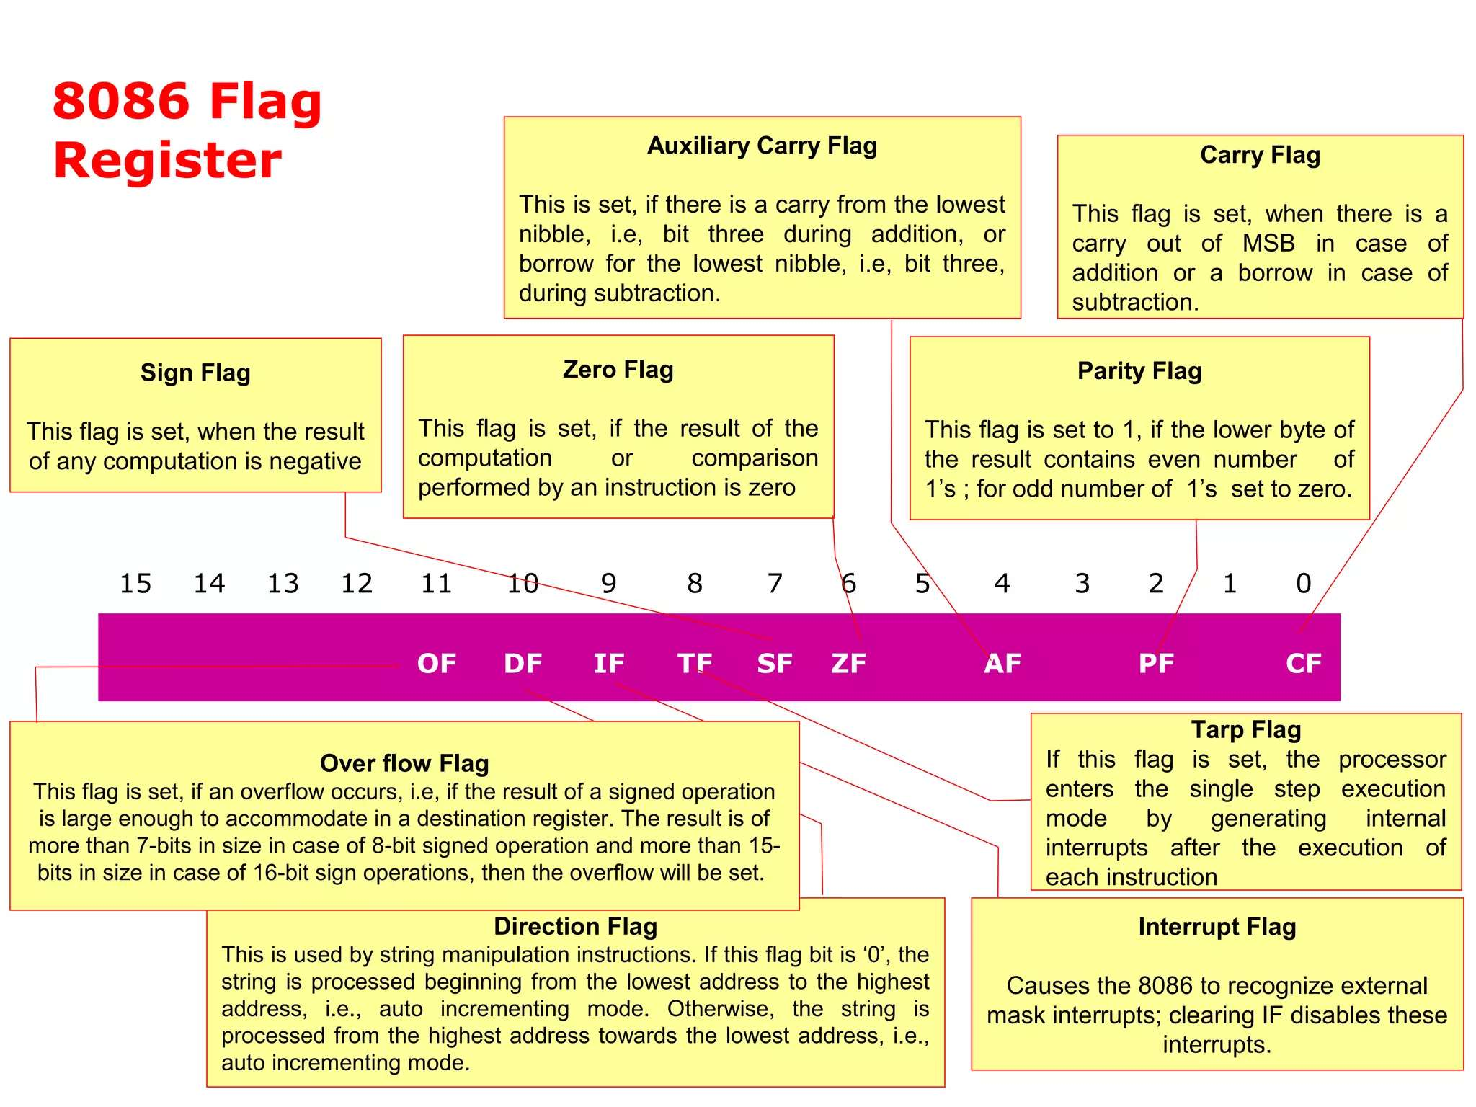
- TF (Trap Flag): Enables single-step mode for debugging.
- IF (Interrupt Flag): Enables or disables maskable interrupts.
- DF (Direction Flag): Controls the direction (increment/decrement) of SI and DI in string operations.

- Explain Immediate, Direct, and Register addressing modes with suitable examples.
Ans:
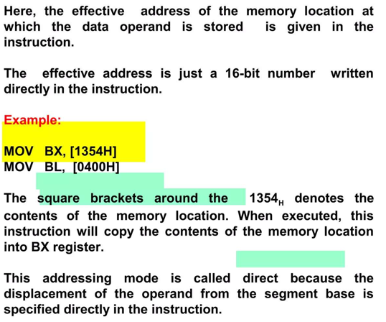
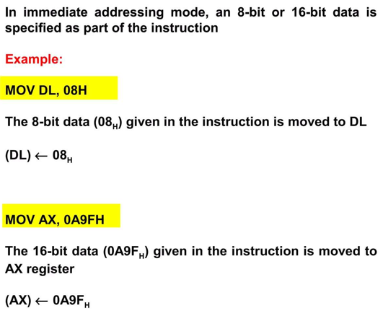
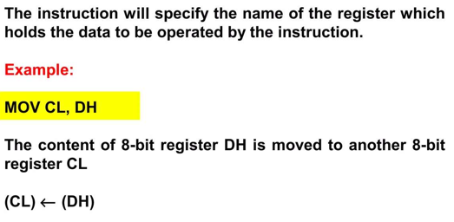

- Explain Register Indirect, Indexed, and Relative addressing modes with suitable examples.
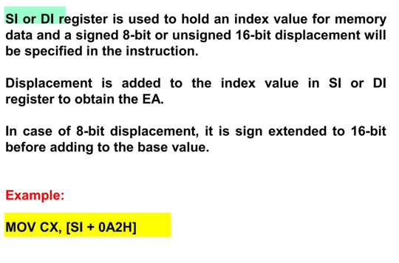
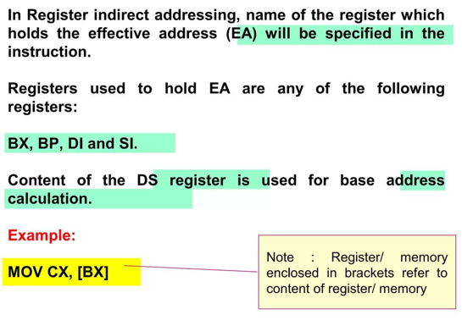
Ans:
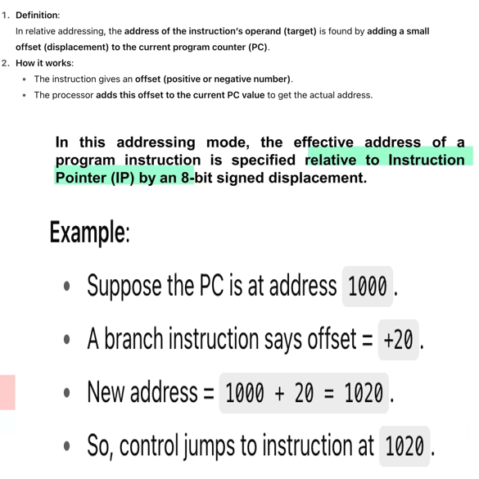

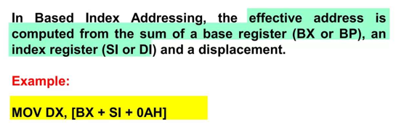
- Explain base addressing, based indexed addressing ,string addressing with suitable examples.
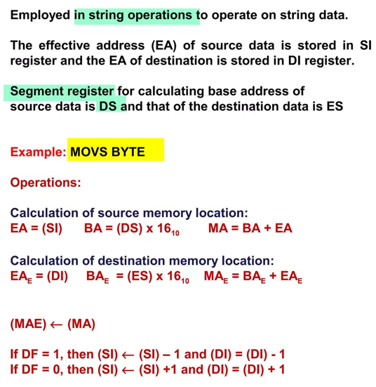
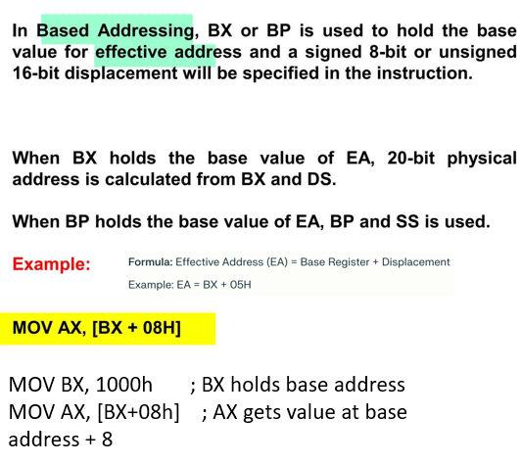
Ans:

- Explain direct and indirect I/O port addressing and implied addressing with suitable examples.
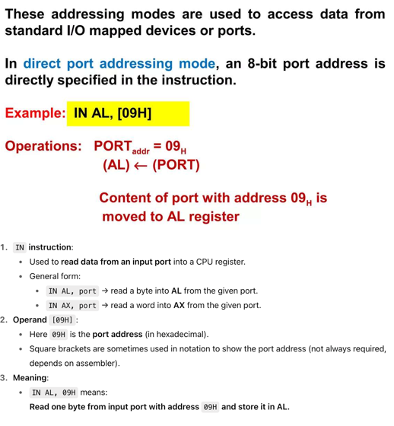
Ans:

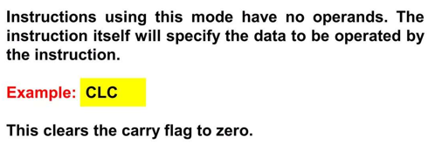

- List different types of instructions supported by 8086 with examples.
Ans:
Data Transfer Instructions These instructions move data between registers, memory, and I/O ports without modifying it.
- MOV (Move): Copies data from a source to a destination.
  - Example: MOV AX, BX copies the content of register BX into register AX.
- IN (Input): Reads data from an I/O port into the accumulator.
  - Example: IN AL, [09H] reads a byte from port 09H into the AL register.

Arithmetic Instructions These instructions perform arithmetic operations like addition, subtraction, multiplication, and division.
- ADD (Add): Adds two operands.
  - (Example not in slides, but this is a standard arithmetic instruction).
- MUL (Multiply): Performs an unsigned multiplication.
  - (Example not in slides, but this is a standard arithmetic instruction).

Branch Instructions These instructions transfer the flow of execution to a different part of the program, either conditionally or unconditionally.
- JZ (Jump if Zero): Jumps to a target address if the Zero Flag (ZF) is set to 1.
  - Example: JZ 0AH jumps 10 bytes forward if the result of a previous operation was zero.

Logic Instructions These instructions perform bitwise logical operations such as AND, OR, and XOR.
- AND (Logical AND): Performs a bitwise AND operation on two operands.
  - (Example not in slides, but this is a standard logic instruction).
- OR (Logical OR): Performs a bitwise OR operation.
  - (Example not in slides, but this is a standard logic instruction).

Bit Manipulation Instructions These instructions are used to set, clear, or test individual bits, including processor flags.
- CLC (Clear Carry Flag): Clears the Carry Flag (CF) to zero.
  - Example: CLC.

String Instructions These instructions are used to process sequences of data (strings) in memory.
- MOVSB/MOVSW (Move String): Moves a byte or word from a source location (DS:SI) to a destination location (ES:DI).
  - Example: MOVS BYTE.

- Explain the general format of 8086 instructions and timing.
Ans:
General Instruction Format
- The standard format for an 8086 assembly instruction is:
- Mnemonic Destination, Source
- Mnemonic: The operation code (e.g., MOV, ADD).
- Destination: The register or memory location where the result is stored.
- Source: The data for the operation, which can be a register, memory location, or a constant value.
Instruction Timing
- Instruction execution time is measured in bus cycles, with each cycle consisting of at least four clock ticks called T-states.
- Read Bus Cycle (Memory/IO Read)
- T1: The CPU outputs the address on the bus and asserts the Address Latch Enable (ALE) signal.
- T2: The Read (RD') signal goes low.
- T3: The CPU reads data from the bus. Slow devices can add wait states (TW) here.
- T4: The RD' signal goes high, ending the cycle.
Write Bus Cycle (Memory/IO Write)
- T1: The CPU outputs the address on the bus and asserts ALE.
- T2: The Write (WR') signal goes low, and the CPU places data on the bus.
- T3: Data is held on the bus to allow the device to capture it.
- T4: The WR' signal goes high, ending the cycle.

- Explain data transfer instructions with examples.
Ans:
MOV (Move)
This is the most common data transfer instruction. It copies a byte or a word from a source operand to a destination operand.
- Syntax: MOV destination, source
- Examples:
  - Register to Register: MOV CL, DH copies the 8-bit content of the DH register into the CL register.
  - Immediate to Register: MOV AX, 0A9FH moves the 16-bit constant value 0A9FH directly into the AX register.
  - Memory to Register: MOV BX, [1354H] copies the 16-bit word from the memory location specified by the direct address 1354H into the BX register. The address is calculated using the Data Segment (DS) register by default.

IN / OUT (Input / Output)
These instructions are used to transfer data between the accumulator (AL or AX) and I/O ports.
- Syntax: IN accumulator, port_address
- Function: The IN instruction reads data from a specified input port and stores it in the accumulator.
- Example: IN AL, [09H] reads one byte from the input port with address 09H and stores it in the AL register.
The OUT instruction (not explicitly shown in the examples, but related) performs the reverse operation, sending data from the accumulator to an output port.

- Explain arithmetic instructions with examples.
Ans:
Key Arithmetic Instructions (General Examples)
- ADD (Add): Adds the source operand to the destination operand and stores the result in the destination.
  - Example: ADD AX, BX would compute AX = AX + BX.
- SUB (Subtract): Subtracts the source operand from the destination operand.
  - Example: SUB CX, 10H would compute CX = CX - 16.
- MUL (Multiply): Performs an unsigned multiplication of the source operand with the accumulator (AL or AX).
  - Example: MUL BL would multiply the value in AL by the value in BL, storing the 16-bit result in AX.
- DIV (Divide): Performs an unsigned division. The dividend is in the accumulator (AX or DX:AX).
  - Example: DIV CL would divide the 16-bit value in AX by the 8-bit value in CL. The quotient is stored in AL, and the remainder is in AH.

- Explain branch instructions with examples.
Ans:
JZ (Jump if Zero)
The JZ instruction is a conditional jump that transfers program control to a new address only if the Zero Flag (ZF) is set to 1 . The Zero Flag is typically set when the result of a preceding arithmetic or logical operation is zero.
- Function: If ZF = 1, the program "jumps" to the new address. If ZF = 0, the instruction is ignored, and the program continues to the very next instruction in sequence .
- Address Calculation: The target address is specified relative to the current Instruction Pointer (IP). The instruction contains a signed 8-bit displacement, which is added to the IP to calculate the new address.
- Example:
JZ 0AH
In this example, if the Zero Flag is set (ZF=1), the processor will add 0AH (10 in decimal) to the Instruction Pointer, causing the program to jump 10 bytes forward and execute the instruction at that new location .

- Explain logic instructions with examples.
Ans:
AND
The AND instruction performs a bit-by-bit logical AND operation between the source and destination operands and stores the result in the destination. It's often used to clear specific bits (masking).
- Example: AND AL, 0FH
  - If AL was 1101 1011, the operation would be 1101 1011 AND 0000 1111.
  - The result in AL would be 0000 1011.
OR
The OR instruction performs a bit-by-bit logical OR operation and stores the result in the destination. It is often used to set specific bits.
- Example: OR BL, 80H
  - This ensures the most significant bit of BL is set to 1, regardless of its previous state.
XOR
The XOR (Exclusive OR) instruction performs a bit-by-bit XOR operation. A bit in the result is 1 if the corresponding bits in the operands are different. It's useful for toggling specific bits or clearing a register by XORing it with itself.
- Example: XOR CX, CX
  - This is a common and efficient way to set the CX register to zero.
NOT
The NOT instruction inverts every bit of its single operand (a one's complement).
- Example: NOT DX
  - If DX contained 0000 1111 0000 1111, after the NOT operation, it would become 1111 0000 1111 0000.

- Explain bit manipulation instructions with examples.
Ans:
Logical Operations
These instructions perform bitwise AND, OR, XOR, and NOT operations. They are often used to selectively clear (mask), set, or invert specific bits.
Example (Masking with AND): To isolate the lower 4 bits of the AL register, you can use AND.
AND AL, 0FH ; Clears the upper 4 bits of AL, leaving the lower 4 unchanged.
________________________________________
Shift Operations
Shift instructions move the bits of an operand to the left or right, which is useful for multiplication or division by powers of 2.
Example (SHL - Shift Left): The presentation gives an example of shifting a number left by one position. SHL AX, 1
If AX contains 0000 0000 0000 1101 (13), after this instruction, AX will contain 0000 0000 0001 1010 (26). This is equivalent to multiplying by 2.
________________________________________
Flag Manipulation Instructions
These instructions directly change the state of specific flags in the flag register.
Example (CLC - Clear Carry Flag): This instruction sets the Carry Flag (CF) to 0. It is often used before an addition operation to ensure there is no initial carry.
CLC ; Sets CF = 0
Example (STD - Set Direction Flag): This instruction sets the Direction Flag (DF) to 1. This causes string operations (like MOVSB) to process data from higher memory addresses to lower ones (auto-decrementing SI and DI).

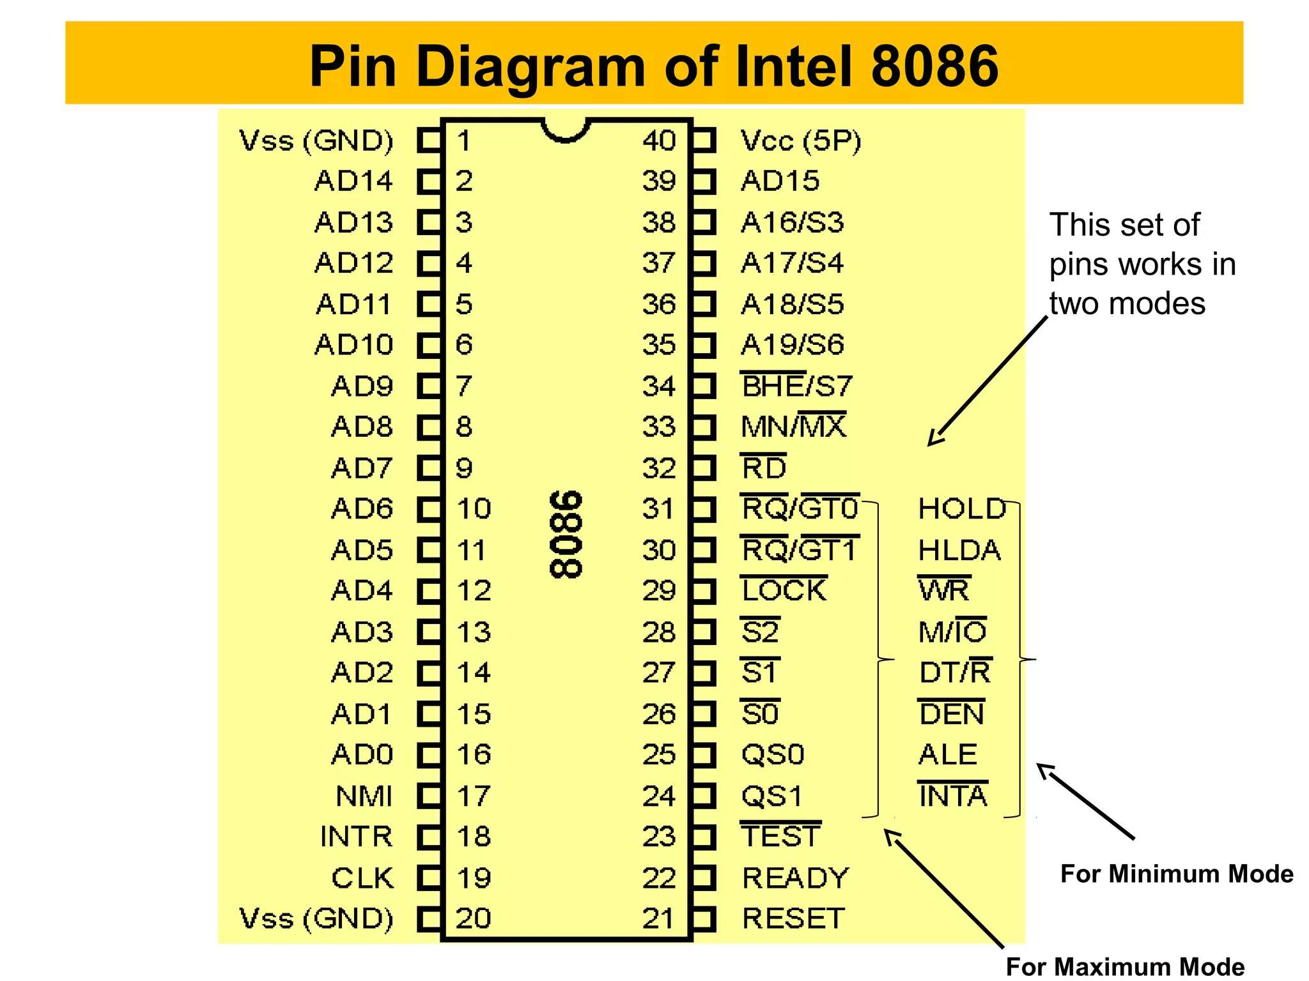
- Draw the pin diagram of 8086 and label the pins.

- Explain the function of multiplexed address/data bus pins (AD0–AD15).
Ans:
- The AD0-AD15 pins are multiplexed to reduce the chip's pin count.
- In the first part of a bus cycle (T1): They carry the lower 16 bits of the memory/IO address. The ALE signal is used to latch this address externally.
- For the rest of the cycle: They function as the 16-bit data bus, transferring data to or from the processor.

- Explain Minimum Mode and Maximum Mode operation of 8086.
Ans:
- Minimum Mode: Selected when the MN/MX' pin is HIGH. This is for single-processor systems. The 8086 generates all bus control signals (like RD', WR', ALE) itself. It's a simpler, less expensive configuration.
- Maximum Mode: Selected when MN/MX' is LOW. This is for multi-processor systems (e.g., with an 8087 coprocessor). The 8086 outputs status codes (S0-S2) which are decoded by an external 8288 bus controller to generate the necessary control signals. This mode provides signals for bus arbitration and is more complex and costly.

- Explain the following pins of 8086: AD0-AD15, BHE’/S7,Ready,RD’
Ans:
- AD0-AD15: Multiplexed address and data lines.
- BHE' / S7: Bus High Enable. An active-low signal used to enable the upper byte of the data bus (D8-D15) for 16-bit or odd-address byte transfers.
- READY: An input from slow memory/IO devices. If low, it forces the CPU into a wait state until the device is ready to transfer data.
- RD' (Read): An active-low output signal asserted by the CPU to read data from memory or an I/O port.
- Explain the following pins of 8086: RESET,INTR,NMI,TEST
Ans:
- RESET: An active-high input that terminates current activity and forces the CPU to start execution from address FFFF0H.
- INTR (Interrupt Request): A maskable interrupt input. External devices use it to request service from the CPU.
- NMI (Non-Maskable Interrupt): An edge-triggered interrupt that cannot be disabled. Used for critical events.
- TEST': An input checked by the WAIT instruction, used for synchronization with a coprocessor like the 8087.

- Explain the following pins of 8086:CLK,VCC,INTA’,ALE
Ans:
- CLK (Clock): Provides the basic timing signal for all processor operations.
- VCC: The +5V power supply pin.
- INTA' (Interrupt Acknowledge): An active-low output signal in Minimum Mode that signals to a device that its interrupt request has been accepted.
- ALE (Address Latch Enable): An output signal indicating that a valid address is on the multiplexed bus, used to trigger an external latch.

- Explain the following pins of 8086:LOCK’, RQ’/GT’,HOLD,HLDA
Ans:
- LOCK': An active-low output in Maximum Mode that prevents other processors from taking the bus, ensuring an instruction executes atomically.
- RQ'/GT' (Request/Grant): Bidirectional pins in Maximum Mode for bus arbitration between multiple processors.
- HOLD: An input in Minimum Mode used by devices like DMA controllers to request control of the system bus.
- HLDA (Hold Acknowledge): An output in Minimum Mode that signals that the CPU has granted the bus to the requesting device.

- Explain the following pins of 8086:WR’,MN/MX’,DEN’DT/R’
Ans:
- WR' (Write): An active-low output in Minimum Mode that signals a write operation to memory or I/O.
- MN/MX': The input pin that selects between Minimum (high) and Maximum (low) operating modes.
- DEN' (Data Enable): An active-low output in Minimum Mode used to enable the external data bus transceiver.
- DT/R' (Data Transmit/Receive): An output in Minimum Mode that controls the direction of data flow through the transceiver. High for transmit (write), low for receive (read).

